**SRM INSTITUTE OF SCIENCE AND TECHNOLOGY, GHAZIABAD**

**A Report Project**

**on**

**Startup Guidance**



Submitted in partial fulfilment of the requirements for the award of degree of Bachelor of Technology in Computer Science

Submitted to :- Submitted by :-

Mr. Rakesh Yadav Prakhar Shukla (RA1711003030515)

Abhishek Kumar Singh (RA1711003030500)

Anurag Singh (RA1711003030496)

Ayush Sahu (RA1711003030510)

**ABSTRACT**

The Start Up Guidance Website is the project which aims in developing the system software such that it predicts the amount of Funding based on the dataset after taking some of the inputs. This project has many features apart from Predicting the Funding of the Start Up, it will tell the Uniqueness of the Start Up. This software would take the inputs of Industry Vertical, Sub Vertical and Investment Type and these inputs would be saving in some Database for the record and the Prediction, Uniqueness of the Start Up is calculated from the Database of 25000 entries in which the Funding of every value is saved .

Nowadays, the life has become so fast that no one has the time to concern for his/her Start Up so this is a very fast working and quick software that tells that the Start Up is fundable or not in seconds. This can be used in the many companies to check their Start Ups.

INTRODUCTION

India is a wannabe super power and with the increasing  population the needs for employment is also increasing. But the amount of factories are limited and so are the job opportunities in the country, the need of the hour for any developing country like India is to promote budding startups and new companies. One of the most popular and successful startup of India is “Paytm” which got funded by one of the biggest company in Asia i.e “Alibaba Group”, successful startups like paytm provide a promising future for the nation in the startup sector.

As simple as it sounds Startup is not that easy of a job , millions of startups fail in India every year, entrepreneurs all over the planet lives quite a stressful life , most of the startups in India fail to find investors because their idea isn’t that unique  or isn’t that popular socially . Paytm wasn’t that successful initially, most of the people in India used cash as payment but on the go it started becoming popular with all the advertisements, offers and cashback it gave, but demonetization  was the ultimate boost for the company. The  budding entrepreneurs get discouraged as they don’t know how unique their idea is! How the startup process works ! Are any companies interested in their Idea ! To cope up with such problems we have created startup guidance .

We have created a platform startup guidance which will help the budding entrepreneurs to analyze how unique their idea is and what are the chances of their startup becoming successful.

Our platform also help them interact with the top investors in the market and get the idea of investment and how the startup industry works. With our forum feature they can have a private chat with any interested investor. With the job opportunities going down in the country , new startups and companies are only the way out to bring new job opportunities for youth in the country.

Startups are essentially of two kinds. One that starts something ground up, something that no one has thought about and is often ground breaking. This type of startup is difficult to create but once created often sees unprecedented growth. The second kind of startups that we see around us are primarily the ones that do not want to reinvent the wheel. They are akin to adding old sauce in a new dish to create something new and innovative.

Whatever may be the kind of startup, Indian startups face its own set of challenges and some stellar opportunities. The challenges can be classified as:

**Culture -** Entrepreneurship and startups are only a recent phenomenon in the country. It is only in the last decade and half that people in the country have moved from being job seekers to job creators. Doing a startup is tough and every country sees more failures than success. More often than not an entrepreneur needs to be prepared to face failures and unprecedented hardship. However, culturally we are not groomed to fail and failure is frowned upon. Entrepreneurship thrives on celebrations and a society that fails to appreciate business failures stifles innovation and creativity even before it can start. A startup failing has to be OK as failures often teach an entrepreneur, what to do and what not to do.

**Mentoring –** Doing a startup is perilous and often a lonely journey. You may have co-founders, but you may not necessarily possess the business acumen to succeed.

Having a brilliant idea is different from making that idea a business success. For a startup, it is very important to have mentors who have been through a similar process of starting or have business experience. A great mentor is often what separates success from failure by providing valuable inputs. However, there is no formal mechanism to mentor startups in the country. Every mentoring that happens is on an ad-hoc basis. A startup that has raised funds can count the investors for some form of mentoring, but honest, unbiased, good business mentors are far and few in between. For startups finding a good mentor is often an uphill task.

**Policies –** Government is the single largest enabler for the entrepreneurial ecosystem. Government's role in ease of doing business and helping companies start is vital to ensuring success. The latest World Bank Ease of Doing Business (out of 189 economies) ranks India at an abysmal 142 where starting a business rank for the country is even lower at 158.

It is uncannily difficult to start a business in India and myriad laws and regulations means it takes about 30 days to comply compared to just 9 days in OECD countries. The government’s role has so far been limited to giving out grants and loans, but without an effective, enabling environment, implementation is far off the target. In this regard it will be interesting to see the contours of the recently announced Startup Fund in this year’s budget. For startups to thrive and succeed, the government has a lot to do and understand the importance of entrepreneurship in economic development.

**Hiring –** The economy has been in a flux and along with the world economy the heady days of high growth are long gone. In an uncertain economy where one is not sure about demand, for a startup, it is particularly difficult to make correct estimates on the number of employees needed. This, however, is the minor problem where the biggest issue is about finding skilled manpower. India’s skilling need is so huge that National Skill Development Corporation (NSDC) has been mandated to skill 150 million Indians by 2022. For a startup, it is particularly difficult to attract and hire talent and skilled workers. A startup often cannot match the salaries drawn at larger companies nor is a job at a startup seen as a steady one. This means startups face severe hiring challenges and at times have to settle for the next best option.

**Funding –** Capital and access to capital has been a perennial problem for startups. While, of late angel investors, venture capital and private equity have brought succor to some extent, a large number of startups still grapple to raise funds from institutional setup. Funding challenge is not merely limited to seed rounds, but also for vital Series A and B rounds. For a startup looking to scale, it is still very hard to raise rounds to scale as the number of investors that write larger cheques in India are very limited in number.

**The opportunities**

**Demographic dividend –** According to the latest UN report India with 356 million 10-24 year-olds have the largest concentration of youth population despite having a smaller population than China. This augurs well for the country as right education and healthcare can see the economy soar. Youth is the driving force behind innovation, creation, and the future leaders of a country. Youth also drives demand and consumption pattern in a country. For startups youth make up the workforce that it so desperately needs and going forward youth can be a huge talent base for startups.

Best suited to address emerging countries’ challenges – India has a unique set of problems that need innovations to originate out of the country. Problems around its health, education, infrastructure, sanitation are unique to the country and solutions from western world cannot solve it. Each problem provides a unique opportunity for startups to solve some pressing issue and at the same time create a business around it. What helps is that most problems around emerging economies are similar in nature and solutions applicable here can also work in many countries in Africa and elsewhere. This enables Indian startups to acquire an even bigger scale and at the same time make a meaningful impact around the world.

**Large population –** For startups in the country, it is not essential to go overseas. India, with over a billion people, present a very large home market for any goods or services. A rising disposable income and growing aspirations of a mushrooming middle class have meant there is a large appetite for brands. The large population has also led to a consumer expenditure growth, which has in turn has propped up supply and production. Startups that look to service and cater to the large population in solving a pain point or providing a utility in one of the world’s most important consumer markets, stand to do well.

**High Mobile penetration –** According to latest Trai figures India's tele-density reached 76.55 percent with a subscriber base of 95.76 crore. Significantly wireless subscriber base touched 95.76 crore, just shy of 100 crore mark. High mobile penetration in urban and rural India has reshaped the economy of the country and how goods and services are offered. It has lead to greater efficiencies and increased productivity. It has meant businesses profit through faster decision making, better logistics and even something like access to bank accounts. Higher mobile penetration has also led to increased financial inclusion and flow of credit to the unbanked. Growth in mobile penetration is transforming the way businesses and consumers communicate and work. With data enabled mobile phones, the very nature of startups and businesses have changed. For example, startups that develop mobile apps now have an ever increasing market to cater to.

India is at crossroads where it now has to cater to the aspirations of a billion people. Existing frameworks can prove to be inadequate and there is a great need to leverage a billion minds and become a global power. Startups and entrepreneurship is the best way forward in becoming a knowledge superpower.

Ashish Mittal is founder and Chief mentor, Turning Ideas, focused on helping multiple startups in mobile, social and cloud domain. He was instrumental in starting Google Enterprise business in India and worked for Microsoft, Oracle and IBM. He is part of advisory board for multiple higher education Institutes and Government and also guides students in becoming Industry ready .He also drives charity for underprivileged known as Turning Life Foundation.

**Uniqueness of your idea**

Uniqueness basically describes that how much one’s idea differ from any other idea. As our project has three main pillar’s prediction, uniqueness, forum. Uniqueness is also an important part of this project in which we will predict the uniqueness of someone’s idea.

Any person who is eager and want’s to start his startup must know about the these things before implementing his first step in the startup world as there is a vast population in this area but only some of them are capable of making through it an d to have their successful startup. It is better if someone could be able to about how much his/her idea is different from other. Then he could understand the success rate of his project.

The technology behind the uniqueness is that we would use scrapping in this department ones idea here would be compared from another. The particular person would have to submit a form regarding  its idea where main points would be the sector of idea from where it is related, the department of idea, and some special things of his project that he would include in his project based upon that we tell the uniqueness of the project.

**Prediction:**

The **PREDICTION** feature of our model predicts the success rate one's startup can have. The Mentee only needs to input certain information about his/her own startup and based on these inputs our model predicts the success rate and tells wheather this startup idea is good idea or bad idea.

The Mentee needs to input these parameters:

* Time of Startup
* Industry Vertical
* Sub Vertical
* City Location
* Investment Type(Private or Seed Funding)
* Amount of Investment

For predicting the success rate of any StartUp, our model uses certain libraries in Python which is called **RANDOM FOREST REGRESSION.**

**RANDOM FOREST REGRESSION**: A random forest is a meta estimator that fits a number of classifying decision trees on various sub-samples of the dataset and uses averaging to improve the predictive accuracy and control over-fitting.

The sub-sample size is always the same as the original input sample size but the samples are drawn with replacement if `bootstrap=True` (default).

**Example**:

 >>> from sklearn.ensemble import RandomForestRegressor

>>> from sklearn.datasets import make_regression

>>> X, y = make_regression(n_features=4, n_informative=2, random_state=0, shuffle=False)

>>> regr = RandomForestRegressor(max_depth=2, random_state=0, n_estimators=100)

>>> regr.fit(X, y)

RandomForestRegressor(bootstrap=True, criterion='mse', max_depth=2, max_features='auto', max_leaf_nodes=None,

min_impurity_decrease=0.0, min_impurity_split=None,

min_samples_leaf=1, min_samples_split=2,

min_weight_fraction_leaf=0.0, n_estimators=100, n_jobs=None,

oob_score=False, random_state=0, verbose=0, warm_start=False)

>>> print(regr.feature_importances_)

[0.18146984 0.81473937 0.00145312 0.00233767]

>>> print(regr.predict([[0, 0, 0, 0]]))

[-8.32987858]

Then the model outputs the predicted value and also recommends what a mentee should do in order to improve the idea of the StartUp.

**Data Set**

A **data set** (or **dataset**) is a collection of [data](https://en.wikipedia.org/wiki/Data). Most commonly a data set corresponds to the contents of a single [database table](https://en.wikipedia.org/wiki/Table_(database)), or a single statistical [data matrix](https://en.wikipedia.org/wiki/Data_matrix_(multivariate_statistics)), where every [column](https://en.wikipedia.org/wiki/Column_(database)) of the table represents a particular variable, and each [row](https://en.wikipedia.org/wiki/Row_(database)) corresponds to a given member of the data set in question. The data set lists values for each of the variables, such as height and weight of an object, for each member of the data set. Each value is known as a datum. The data set may comprise data for one or more members, corresponding to the number of rows.

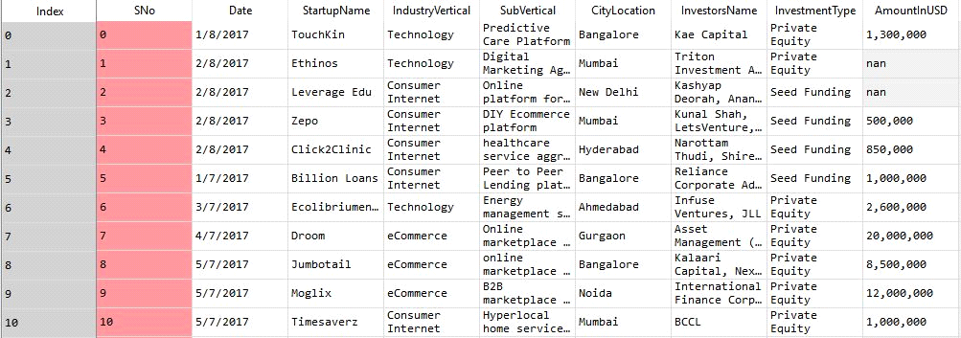

The data sets are extracted from :-

<https://data.world/datasets/startups>

<https://www.kaggle.com/sudalairajkumar/indian-startup-funding>

<https://angel.co/companies>

<https://www.reddit.com/r/datasets/comments>

First of all we should know that we need to do some more "Behavioral Diagrams" that show what should happen on the system, to give a deeper understand about how to design the "Structure Diagrams" which describe the system more technically if I should say. Example of behavioral diagrams are Use Case diagrams and Sequence diagrams.

* ***Structure diagrams*** *show the things in a system being modeled. In a more technical term they show different objects in a system.* ***Behavioral diagrams*** *shows what should happen in a system. They describe how the objects interact with each other to create a functioning system.*

Then we have to go through in brief

* ***Class diagrams*** *show the classes in a system, attributes and operations of each class and the relationship between each class. In most modeling tools a class has three parts, name at the top, attributes in the middle and operations or methods at the bottom. Different relationships between diagrams are show by different types of Arrows.*

  ┌─────────────────────────┬

  │  Users                  │

  ├─────────────────────────┬

  │id: int                  |

  |username: String         |

  |password: String         |

  |email: String            |

  |forum_notification: bool |

  ├─────────────────────────┼

  |+logIn()                 |

  |+logOut()                |

  |+Reqigster()             |

  |+CreateTopic()           |

  |+EditTopic()             |

  |+AddNewPost()            |

  |+EditPost()              |

  |+DeletePost()            |

  |+SendMessage()           |

  |+ReportIssue()           |

  ├─────────────────────────┼

            | ..1

            |

            |

            |

            |

            | 0..*

  ┌─────────────────────────┬

  │  Posts                  │

  ├─────────────────────────┬

  │id: int                  |

  |category_id: int         |

  |topic_id: int            |

  |post_creator: int        |

  |post_content: String     |

  |post_date: DateTime      |

  ├─────────────────────────┼

  |+PostDelete()            |

  |+PostUpdate()            |

  |+UpdateContent()         |

  |+GetViewers()            |

  |+ChangeCategory()        |

  ├─────────────────────────┼

**FLOW CHART**

A flow chart is a graphical or symbolic representation of a process. Each step in the process is represented by a different symbol and contains a short description of the process step. The flow chart symbols are linked together with arrows showing the process flow direction.

**Unified Modified Language Diagrams**

This UML class diagram explains about the working of our model. It gives a brief overview of our project "STARTUP GUIDANCE".

The front page of our project consists of login and signup page using which we can use the features of our model such as **PREDICTION, UNIQUENESS AND FORUM**.

The login and signup have two options by which a user can use: first option is **Mentee** and second option is **Investor**.

In Mentee option, the user needs to input several parameters like:

* Name
* Email Id
* Date of Birth
* Registration ID
* SignUp Date
* Intrested Sector

In Investor option, the  user needs to input several parameters like:

* Name
* Email Id
* Password
* Submitted Documents
* Date of Birth
* Registration Id

The then above parameters are then passed to our server. The server is too divided into two parts:

* Member Server
* Investor Server

The information given by Mentees and Investors are then stored in member server and investor server respectively.

The above information are then used by our model to use our star features: Prediction and Uniqueness.

**Use Case Diagram**

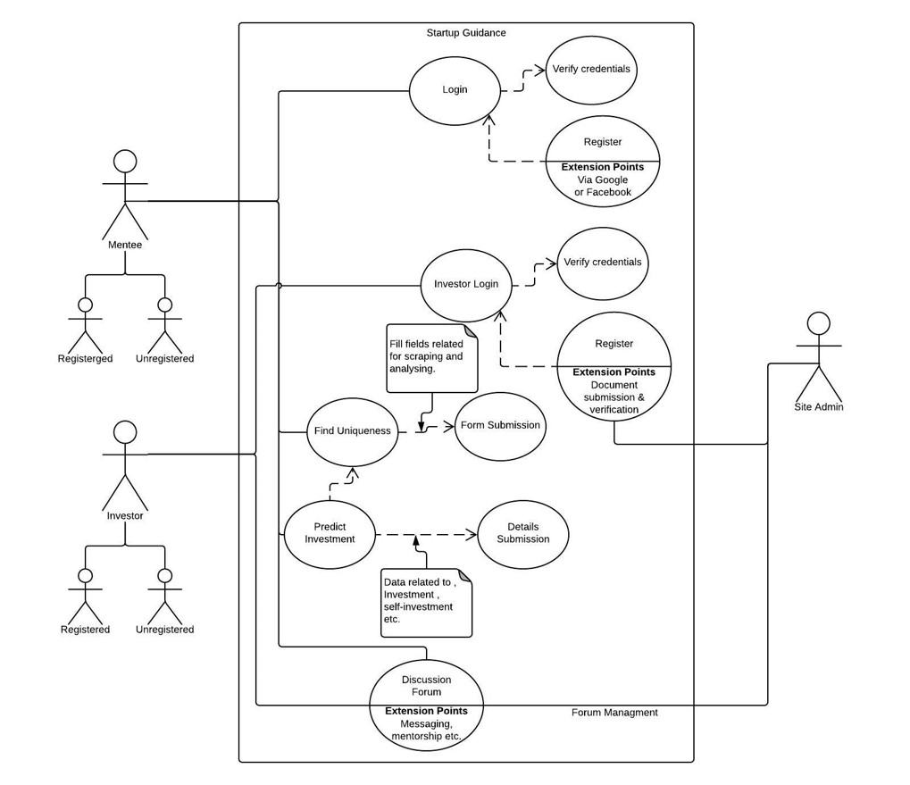

A UML use case diagram is the primary form of system/software requirements for a new software program under developed. Use cases specify the expected behavior (what), and not the exact method of making it happen (how). Use cases once specified can be denoted both textual and visual representation (such as UML). In the above use case diagram , we  have specified the behavior of startup guidance and the exact method of it happening . There are basically two users of the features one is mentee and other is  investor,both have different login

after login via google or sign up on the site itself the user uses feature like prediction and uniqueness and forum aswell, the mentee use feature of forum to intercat with the mentee.

**Class Diagram**

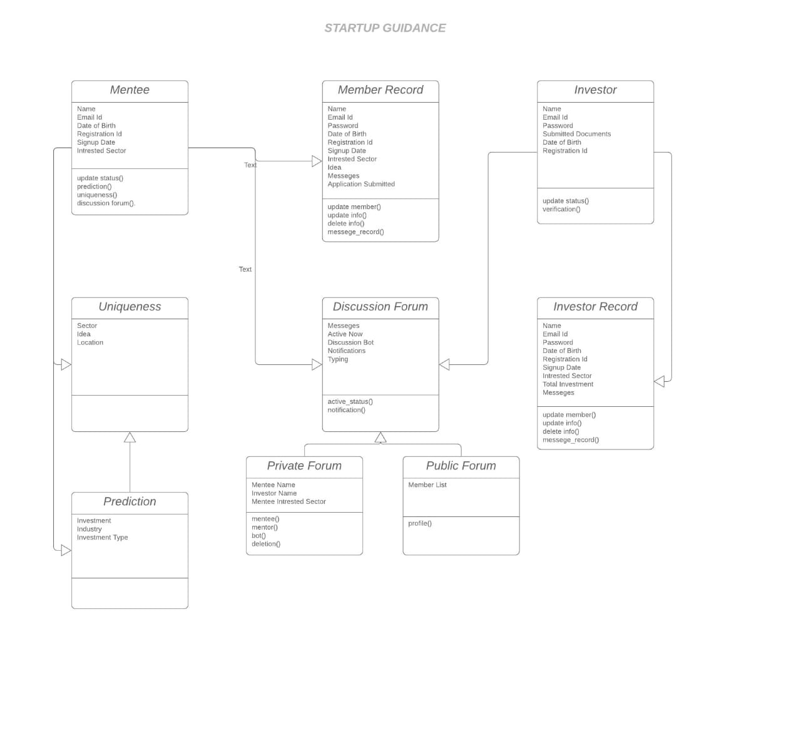

In software engineering, a ***class diagram*** in the Unified Modeling Language (***UML***) is a type of static structure ***diagram*** that describes the structure of a system by showingm the system's ***classes***, their attributes, operations (or methods), and the relationships among objects. In the above class diagram of Startup Guidance , we have different classes like mentee , member record,forum etc . that contains object like name, id and other personal information of mentee which later get stored in the member record as object. in discussion forum we have objects like messages , active now, typing etc . that gives the info about the current situation of the mentee or investor in the discussion forum.

**Basic Sequence Diagram**

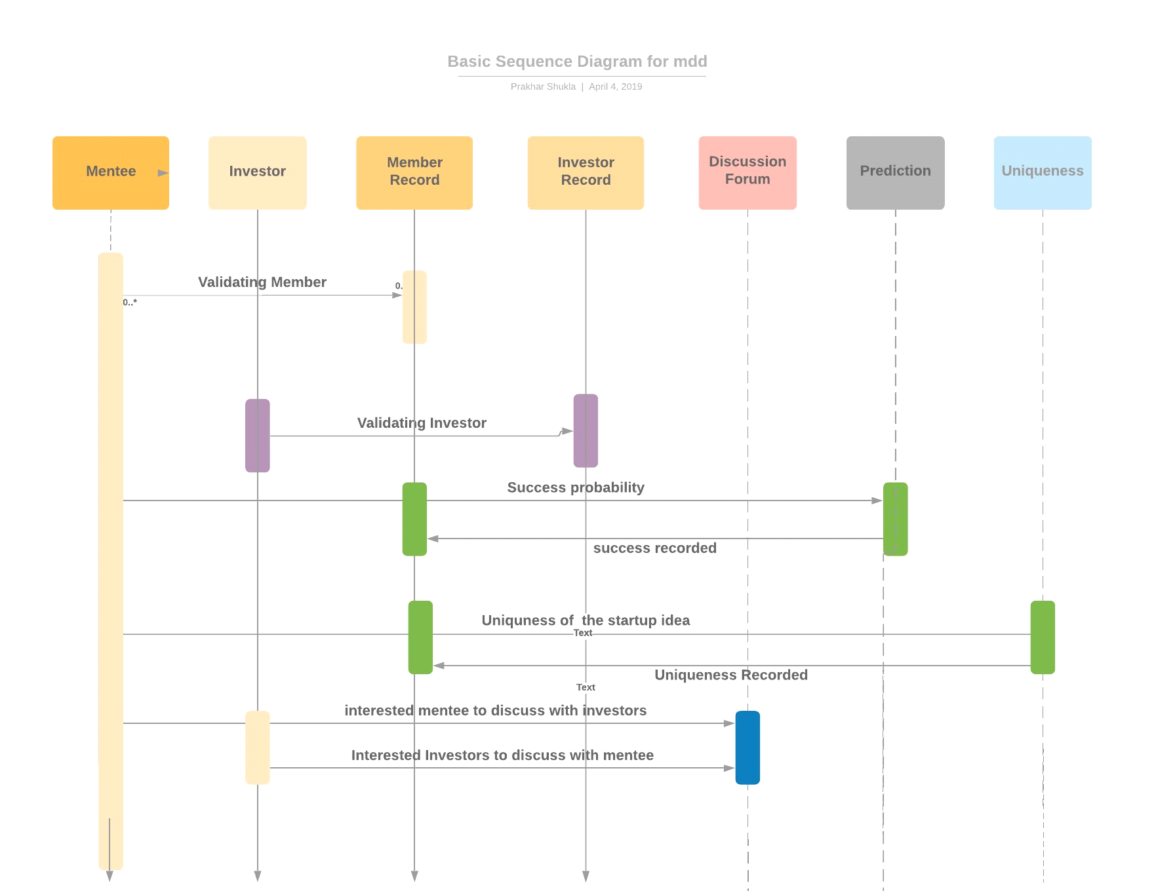

Sequence diagrams describe interactions among classes in terms of an exchange of messages over time. They're also called event diagrams. A sequence diagram is a good way to visualize and validate various run time scenarios. These can help to predict how a system will behave and to discover responsibilities a class may need to have in the process of modeling a new system.

The above startup guidance sequence diagram shows the interaction between mentee and investor . It sequentially shows how the mentee goes to the prediction feature and use it and come back and also shows how it goes to the uniqueness of idea feature . It also shows how both the mentee and investor reach and interact at the forum.

**Collaborative Diagram**

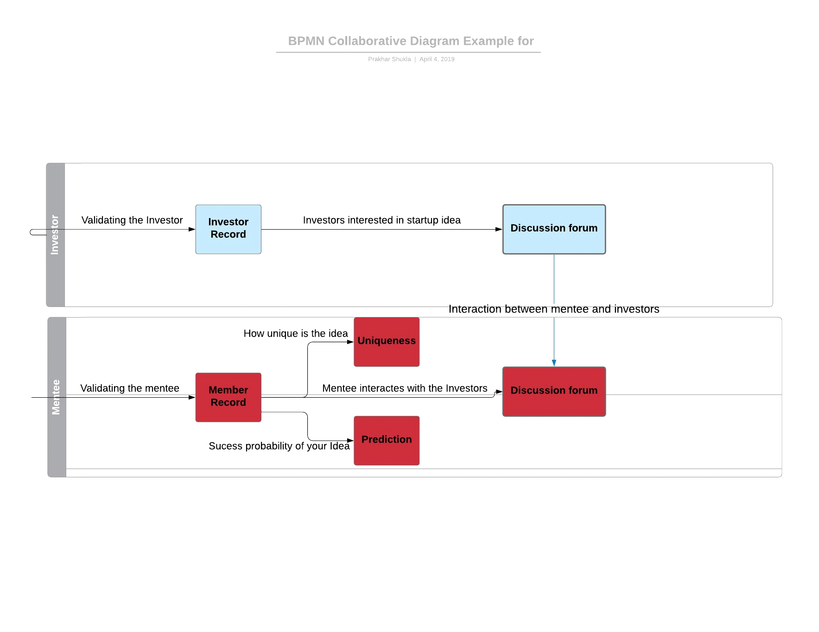

UML Collaboration diagrams (**interaction diagrams**) illustrate the relationship and interaction between **software objects**. They require use cases, **system operation contracts**, and domain model to already exist. Similar to sequence diagram collaboration diagram also shows the  interaction between different entities in the startup guidance , it is drawn using the use case diagram that we have already proposed and drawn.In the above diagram we see it has two different block for both mentee and investor and shows their interaction with prediction , uniqueness and forum .

**State Diagram**

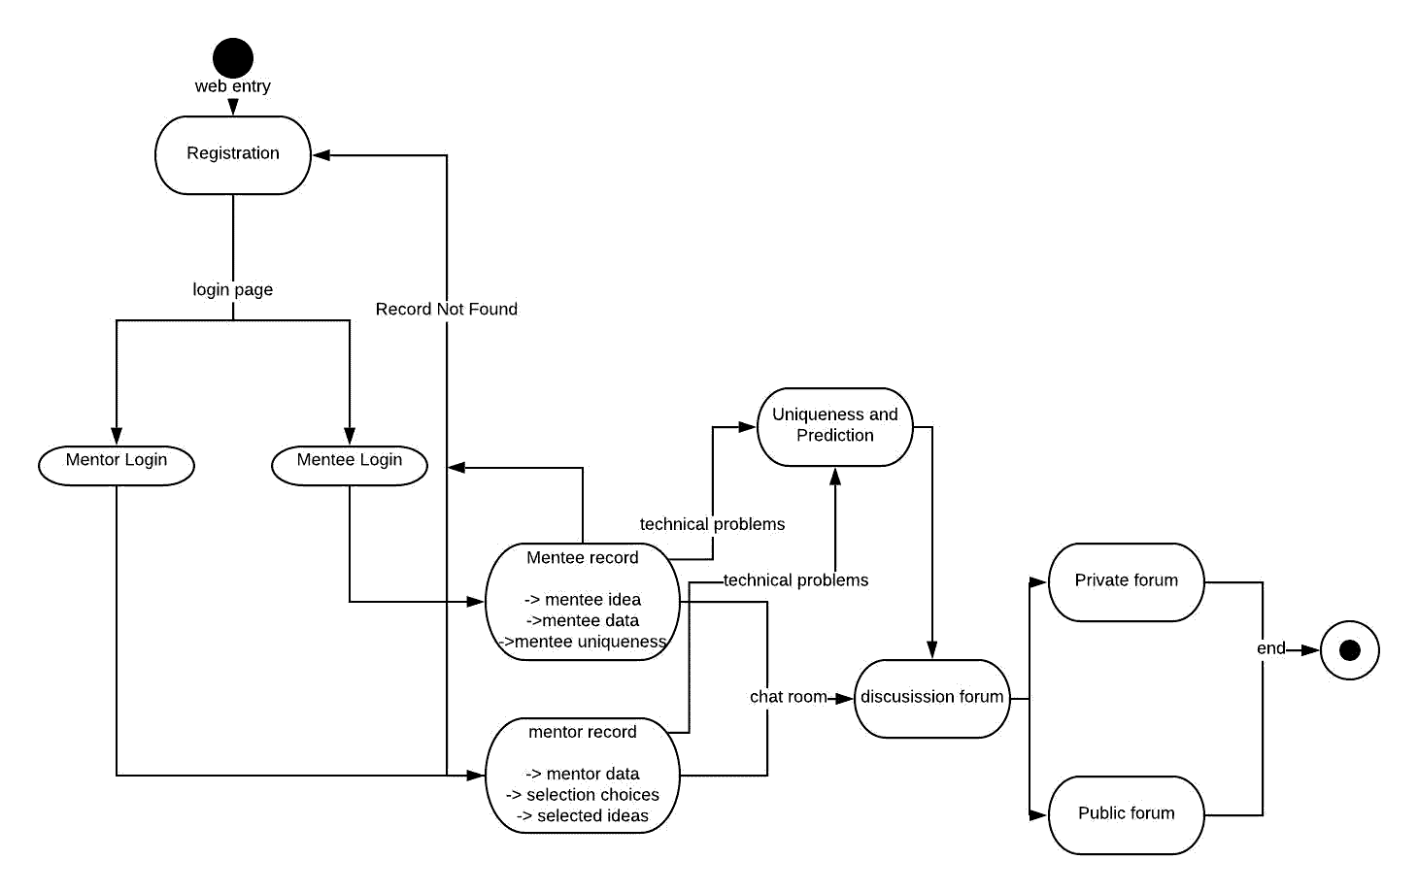

A **state diagram** is used to represent the condition of the system or part of the system at finite instances of time. It’s a **behavioral** diagram and it represents the behavior using finite state transitions. State diagrams are also referred to as **State machines** and **State-chart Diagrams**.

In the above startup guidance state diagram we can see , that it shows the working of mentee and mentor at different instances of time . At a particular instance we check the member record , if it is found then it is shown other member record is not found is displayed  and we go back to the previous page. after checking the member the next instance is to show its features like prediction and uniqueness and discussion forum if all the member record is successfully found.

**Technology Stack**

The overall architecture of the whole web app is represented via the below architecture diagram.

* Django: The web-app is primarily implemented in the Django Python web framework.
* HTML templates, JavaScript, etc. (open source libraries like Jquery etc. will be used) Jinga2 template engine will be used.
* NGINX/Apache can be used in production. We are using Django dev web server for development.
* MySQL is the database that stores all the persistent data.
* ML using Python operated by Spyder console using libraries like Numpy, MatPlotLib, Pandas and ScikitLearn, TF-IDF.

**Hardware and Software Specification**

**Recommended System Requirements**

* Processors:
* Intel® Core™ i5 processor 4300M at 2.60 GHz or 2.59 GHz (1 socket, 2 cores, 2 threads per core), 8 GB of DRAM
* Intel® Xeon® processor E5-2698 v3 at 2.30 GHz (2 sockets, 16 cores each, 1 thread per core), 64 GB of DRAM
* Intel® Xeon Phi™ processor 7210 at 1.30 GHz (1 socket, 64 cores, 4 threads per core), 32 GB of DRAM, 16 GB of MCDRAM (flat mode enabled)
* Disk space: 2 to 3 GB
* Operating systems: Windows® 10, macOS*, and Linux*

**Minimum System Requirements**

* Processors: Intel Atom® processor or Intel® Core™ i3 processor
* Disk space: 1 GB
* Operating systems: Windows* 7 or later, macOS, and Linux
* Python* versions: 2.7.X, 3.6.X
* Included development tools: conda*, conda-env, Jupyter Notebook* (IPython)
* Compatible tools: Microsoft Visual Studio*, PyCharm*
* Included Python packages: NumPy, SciPy, scikit-learn*, pandas, Matplotlib, Numba*, Intel® Threading Building Blocks, pyDAAL, Jupyter, mpi4py, PIP*, and others.

**Software**

* PIP and NumPy: Installed with PIP, Ubuntu*, Python 3.6.2, NumPy 1.13.1, scikit-learn 0.18.2
* Windows: Python 3.6.2, PIP and NumPy 1.13.1, scikit-learn 0.18.2
* Intel® Distribution for Python* 2018

**Modifications**

* Scikit-learn: Conda*-installed NumPy with Intel® Math Kernel Library (Intel® MKL) on Windows (PIP-installed SciPy on Windows contains Intel MKL dependency)
* Black-Scholes on Intel Core i5 processor and Windows: PIP-installed NumPy and Conda-installed SciPy

**Resources and Inference**

* Django backend and the related queries were referenced from
* <https://docs.djangoproject.com/en/2.2/>
* Html , CSS and JS related queries were solved using
* <https://www.w3schools.com/>
* The datasets where taken from
* <https://www.kaggle.com/>
* The project was maintained at
* <https://www.github.com/>
* The documentation was written via collaboration through
* <https://www.dropbox.com/>

**OUTPUT SCREEN:**

